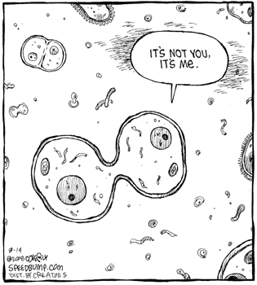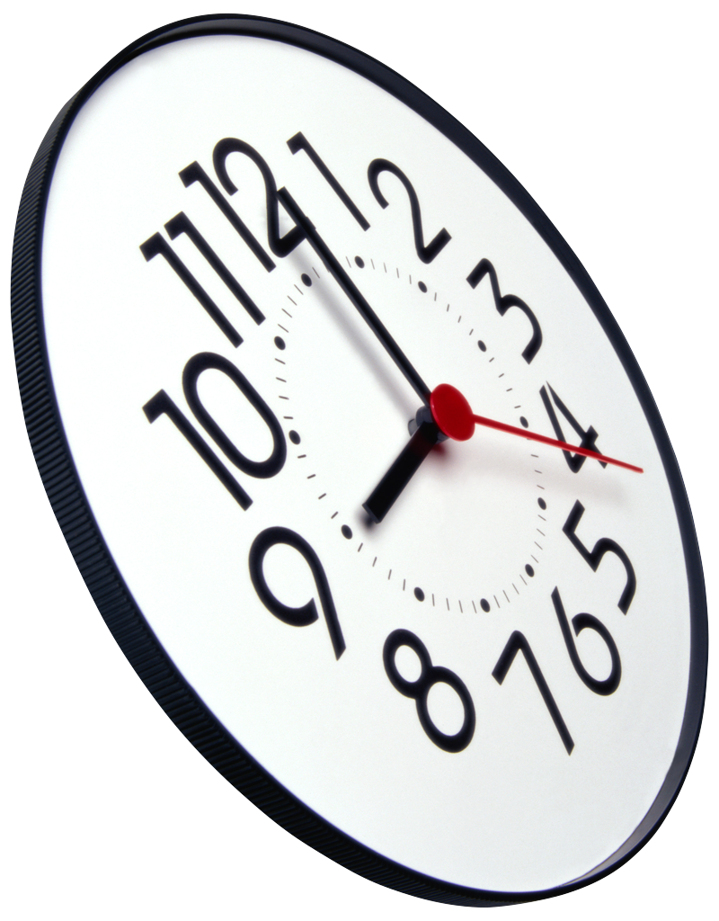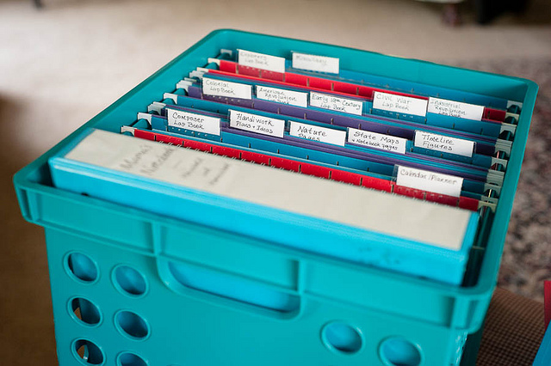

Online Textbook

7th grade

User name = science 796

 Password = cells

Email: [livack@rivergroveschool.org](mailto:livack@rivergroveschool.org)

Twitter: @msivack

Phone Number: (708) 453-6172 ext. 226

Website: Go to rivergroveschool.org and click the “Teachers’ Websites” tab to find my page.

Contact Ms. Ivack

2015 - 2016

This year we will be studying biology with a focus on cells, the building blocks of life. We will begin by learning about cells, parts of cells, and how they function. From there, we will understand how cells work together to carry out processes as well as how genetic information is passed along from organism to organism. Lastly, we will classify organisms and learn the characteristics of life with a focus on animals. During this course, you will also have the opportunity to take part in multiple laboratory activities.

**Topics**

* Lab Safety
* Chapter 1 – Cells: The Basic Unit of Life
* Chapter 2 – The Cell in Action
* Chapter 3 – Heredity
* Chapter 4 – Genes and DNA
* Chapter 7 – Classification

River Grove School

7th Grade Science

# Course Description

In addition to having these materials each day, you must be on time each day! If you are late to class, you will be marked tardy. After three tardies, a 4:00 detention will be issued. Any subsequent tardies will result in a 5:00 detention being issued. This cycle will restart at the beginning of each quarter.

Come to Class on Time!

-Textbook- If you forget your textbook at school, you may access it on my website. In addition to coming to class with your textbook, it is also your responsibility to cover the book and keep it in good condition.

-Binder/Folder- All chapter handouts, notes, and graded homework will be kept in your binder or folder. It will be used for science ONLY and must be kept organized and up to date. If you choose to use a binder, a 1.5 or 2 inch binder will work best.

-Pencil/Pen/Highlighter

-SmartBook

**Please be responsible and come to class with all of your materials each day.**

### **Chapter Expectations**

-Reading assignments will help you with homework, vocabulary, and studying.

-Vocabulary will be assigned for homework and will appear on quizzes and tests.

-Worksheets will include directed readings, diagrams, charts, or outlines.

-Labs will be explained prior to doing them. You are to follow the directions closely. Inappropriate behavior will result in exclusion from the lab activity.

-Projects are explained in class and will have specific directions.

-Tests - Tests are given every 3-4 weeks.

**-**Science World – You will be required to read and reflect on an article from these magazines

-Daily 7/8 – These short questions will give you a quick review of important science concepts or topics which will help prepare for standardized tests.

**Materials**

If you are not in class, it is your responsibility to check the absent calendar and take the work from the bin. You will have the same number of days you were absent to complete the assignment. If you have questions about the work, you must ask a friend or see Ms. Ivack.

If you need to redo an assignment or need an extra copy, you must also get the work from the bin.

This is your responsibility. I will help you with the work, but I will not prepare the work for you.

Late Work

* Late work will not receive full credit.
* Late work results in referral to academic lunch. The assignment should be turned in after the academic lunch and will not be accepted any later.
* Homework Pass: One homework pass will be issued per quarter. The pass allows for one homework assignment to be accepted ONE day late and still receive full credit. Put the pass in a safe place, as there are no replacements if lost. If you do not use your homework pass all quarter, you may redeem it to dismiss your lowest homework grade.
* Homework can always be hung on the clip outside of the classroom if Ms. Ivack is not in the room.

Absent Work and Missing Work

All work must be completed with a pen or pencil unless specified otherwise. Please remember to put your name and class period on the top of the page. The work you turn in must be completed neatly. Sloppy work will be returned to complete neatly and will not receive full credit

Grading Scale

A 100% - 90%

B 89% - 80%

C 79% - 70%

D 69% - 60%

F 59% - 0

Homework Policy

Donec varius, felis eget lobortis vehicula, magna sapien elementum tellus, ut iaculis dui orci sed arcu. Nullam semper leo.

1st time = Warning

2nd time = Warning and possible seat change

3rd time = Quiet Lunch

4th time = Detention and contact home

*Severe clause = Sent to office to be dealt with by the administration.

Rewards for

Positive Behavior

Consequences for

Violations of Rules

**1. Be Respectful**

raise your hand to share, be polite, listen to others, keep your hands to yourself

**2. Be Responsible**

do your homework, come prepared to class, be on time, report unsafe or unkind behavior

**3. Be Safe**

listen to directions, follow safety procedures

**4. Be Kind**

help others, include others, no whispering, no gossiping, stick up for others, smile

1. Royal Rewards
2. Good news home (note, email, phone call)
3. Raffles
4. Success and good grades!

**Classroom Procedures**

**Entering the classroom:** You are expected to enter the room quietly and respectfully. As soon as you enter, take your seat and take out the previous day’s homework and the materials you will need.

**Leaving the classroom:** You are allowed to sign out without consequences **two** times per quarter. Leave the room only with permission. I need to know where you are at all times.

**Restrooms**: Use the restroom during passing periods. Have a friend tell me you will be late or drop your books off and tell me yourself. This will not count as a sign out or a tardy as long as you get to class within minutes after the bell. However, if you wait until class begins and then decide to use the restroom you will need to use a sign out.

**Homework Check-In:** Some homework will be “checked-in” for points. You will receive points based on completeness and effort.

**Homework Turn-In:** Other homework will be turned in. This will be collected at the beginning of class.

**Classroom Rules**